**THE UNIVERSITY OF BRITISH COLUMBIA**

**OKANAGAN CAMPUS**

FACULTY OF APPLIED SCIENCE, SCHOOL OF ENGINEERING



MANF 460

**MANF 460 Project Report 1**

**Prepared for: Dr. Babak Mohamadpour Tosarkani**

**Date: October 20, 2023**

**Prepared by:**

**Maki Benedicto** (98610801)

**Alexander Leung** (45240421)

**Agam Aneja** (65683799)

**Muskan Garg** (61473765)

**Muhammed Irtaza Raza** (36541340)

**Application of MOORA to Rank Battery Types for Electric Light Aircraft**

# 1. Introduction

In the current aviation sector, the quest for sustainability and reduced carbon emissions is not just a trend, but a pressing necessity. The aviation industry is undergoing a significant shift towards greener technologies, marking an impending transformative period. Electric light aircraft, which could play a pivotal role in this shift, represents a convergence of innovation, technology, and environmental responsibility. Specifically designed for the smooth transportation of four passengers over a 1000-kilometer range, these aircraft demand a reliable and sustainable energy source to meet their operational needs. This choice of power source holds paramount importance in determining the aircraft's overall performance, environmental impact, and market feasibility, aligning with the industry's growing focus on sustainable solutions.

The battery, a vital component in this aircraft, determines the performance, range, and overall feasibility of the aircraft. The market offers a plethora of competitive battery types, each with distinct attributes and performance metrics, adding complexity to the task of choosing the ideal solution. Such a decision cannot be based on a single criterion; Rather, it requires a holistic evaluation that takes into consideration various technical, economic, and environmental factors.

Multi-Objective Optimization by Ratio Analysis (MOORA) is a powerful decision-making tool that has gained considerable traction in the realm of supply chain management. This methodology aims to provide a structured framework for evaluating and selecting suppliers, products, or logistics strategies based on multiple, often conflicting, criteria. MOORA facilitates the complex process of decision-making by enabling supply chain members to consider various aspects simultaneously, such as cost, quality, lead time, and environmental impact.

In supply chain management, MOORA's significance lies in its ability to boost efficiency, lower costs, enhance sustainability, and support the selection of solutions aligned with an organization's specific goals and priorities. This report employs the MOORA method to rigorously evaluate, analyze, and rank various battery types. Our clear objective is to provide a data-driven recommendation for the battery type that best suits the electric light aircraft's needs. Through a meticulous assessment, this study bridges the divide between innovation and practical implementation, ensuring the project is visionary yet grounded in empirical research.

# 2. Criteria for Evaluation

Choosing the right battery type, much less one intended for use in an aircraft, is a complex task that requires a strong evaluation system. Our framework relies on real-world research and industry standards, including a set of criteria that give us a complete view of each battery's pros and cons. It's important to note that while some criteria highlight the good aspects of a battery, others point out areas of concern or potential issues. This balanced approach to evaluation ensures a well-rounded and thorough assessment, allowing us to make informed decisions that account for all relevant aspects of battery performance, safety, and suitability for aircraft application.

**2.1 Positive Criteria:**

1. **Specific Energy (Wh/kg)**: In aviation, weight is a critical consideration. Specific energy measures how much energy a battery can store per unit weight. A higher value implies the battery can store more energy for a given weight, directly influencing the aircraft's potential range.
2. **Volumetric Energy Density (Wh/L)**: Aircraft design often faces space constraints. Volumetric energy density represents the amount of energy a battery can store within a given volume. Batteries with higher volumetric energy densities are advantageous as they allow for compact configurations without compromising energy storage.
3. **Battery Charging Rate (Wh/hr)**: Efficient turnaround times are crucial in aviation. The battery's charging rate, indicating how quickly it can replenish, affects the aircraft's readiness for subsequent flights.
4. **Charge Durability (cycles)**: The operational lifespan of a battery is gauged not just in terms of years but also in the context of charge-discharge cycles. A battery that can withstand a higher number of cycles before significant degradation ensures longevity and reduces the frequency of replacements.
5. **Company Responsiveness**: The technical prowess of a battery is just one side of the coin. The agility and responsiveness of the manufacturing company play a pivotal role in addressing potential issues, ensuring timely support, and facilitating seamless integration with the aircraft's systems.
6. **Company Reliability**: The historical performance and reliability of a company offer insights into the quality and consistency of their products. Established track records often indicate a company's commitment to excellence and their ability to deliver on promises.

**2.2 Negative Criteria:**

1. **Relative Price ($/kWh)**: Economic considerations are integral to the viability of any project. The cost of the battery, benchmarked against its energy storage capacity, provides a metric for assessing the financial implications of the selection.
2. **Environmental Impact of Production**: As global emphasis on sustainability intensifies, the ecological footprint of battery production becomes a focal point of evaluation. Batteries that are produced with minimal environmental impact align with global green initiatives and ensure regulatory compliance.
3. **Cell Count for Desired Voltage**: The technical specifications of a battery, particularly the number of cells required to achieve the desired voltage, influence its design, efficiency, and potential integration challenges.

# 3. MOORA Analysis

The process of selecting an optimal battery type for the electric light aircraft is multifaceted. With numerous battery options available, each having unique features and performance data, a systematic and analytical approach is crucial. The MOORA method serves as a robust tool in this endeavor, providing a structured mechanism to evaluate and rank the various battery alternatives.

**3.1 Decision Matrix:**

The initial step in the MOORA method involves the construction of a decision matrix. This matrix presents the raw performance scores of each battery type against the established criteria. The values in this matrix represent the actual metrics associated with each battery type for every criterion, as can be seen below.

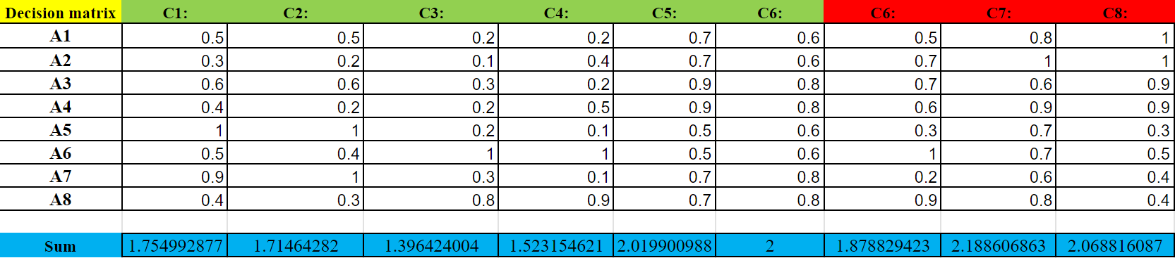

**3.2 Normalization:**

Given the varied units and scales of the criteria, normalization is essential to ensure comparability. The normalization process adjusts the values in the decision matrix to bring them onto a common scale, allowing for a more coherent analysis. The following table represents the normalized decision matrix.

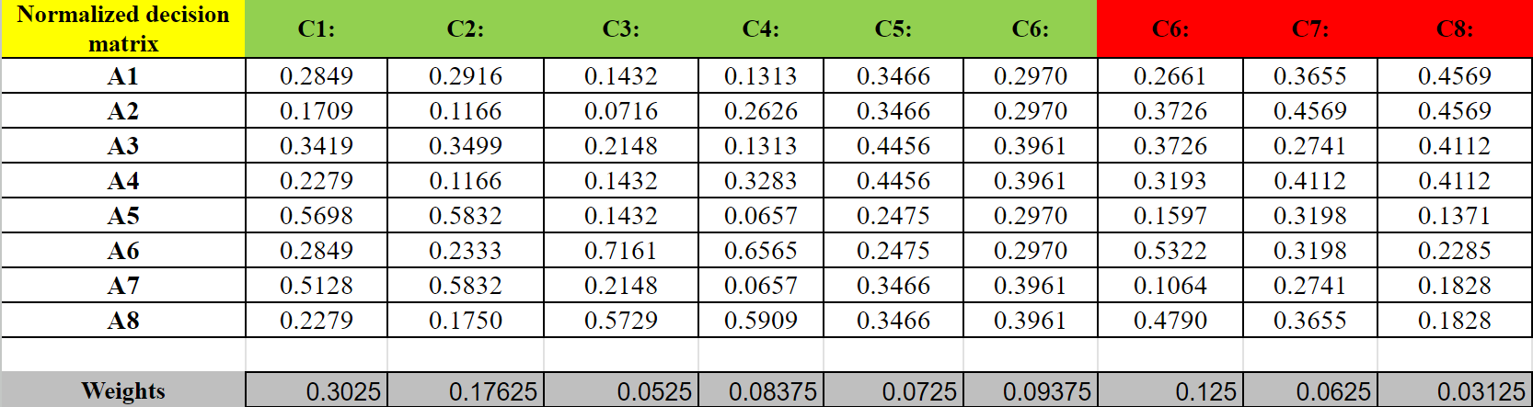

**3.3 Weighted Normalized Decision Matrix:**

While the normalization process ensures comparability, it's crucial to recognize that not all criteria carry equal importance. The next step involves assigning weights to each criterion, reflecting its significance in the decision-making process. The weighted normalized decision matrix is derived by multiplying the normalized values by their respective weights, as can be seen below.

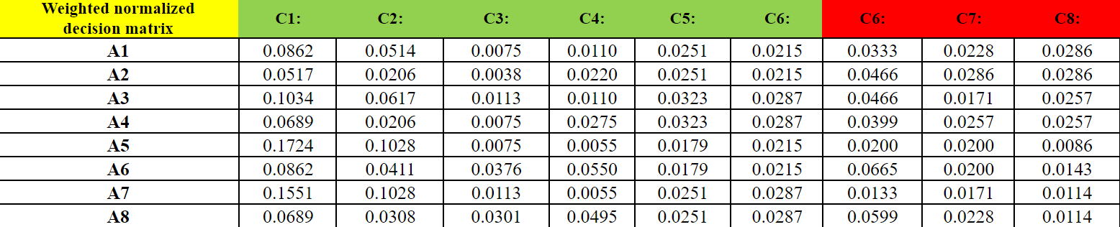

**3.4 Final Ranking:**

With the weighted normalized decision matrix in place, the final step involves calculating the overall score for each battery type and subsequently ranking them. This ranking is pivotal as it offers a clear recommendation based on a rigorous analytical process.

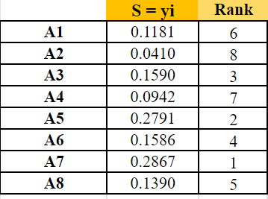

# 4. Conclusion

The objective of this study was anchored in the complex challenge of selecting an optimal battery type for an electric light aircraft designed to carry four passengers over a distance of 1000 km. Given the aviation industry's significant shift towards sustainability, the magnitude of this decision cannot be overstated. A well-suited battery is the linchpin for the aircraft's success, directly influencing its performance, range, and operational viability. This decision holds implications for the broader efforts to reduce the aviation industry's environmental footprint and enhance efficiency.

To navigate this complex decision-making process, our study applied the MOORA method, a robust analytical tool adept at evaluating multiple alternatives against a carefully curated set of comprehensive criteria.These criteria were thoughtfully selected to encompass technical, economic, and environmental factors, forming the framework for our evaluation. This approach ensured a comprehensive assessment of important factors encompassing essential aspects such as battery performance and cost-effectiveness.

Following a thorough MOORA analysis, "*Battery Type A7- Lithium-ion polymer battery from company D*" emerged as the top-ranked solution. This battery type demonstrated an optimal balance across the criteria, making it the most suitable choice for the electric light aircraft. The selection of "A7" is not just a testament to its technical prowess but also underscores its alignment with the broader objectives of sustainability, cost-effectiveness, operational efficiency, and environmental impact.

In conclusion, the insights from this study offer a clear path for the electric light aircraft project, grounding the vision of sustainable aviation in robust research and analytical rigor. Selecting "Battery Type A7" represents a practical step towards the aviation industry's environmental and efficiency goals, emphasizing the importance of evidence-based decision-making for a more sustainable aviation future.